Database:::

* A database is an organized collection of data that is stored and accessed electronically.
* It is so incredibly powerful at getting the data out in exactly the format you want.

Cosmos DB::

Having data near your users is a key in providing the best experience for your users. Databases of old were notoriously difficult to set up across multiple locations, and keeping them in sync.

@@ For example, if you have the data in the region of US East, West Europe, and South Africa and want to expand to Australia, all you have to do is click on that region in the Azure portal to enable it.

* Azure then takes care of moving the data and keeping it in sync
* It will take very less time/Low latency
* Although you are paying for what you use, Cosmos Db is bit expensive.

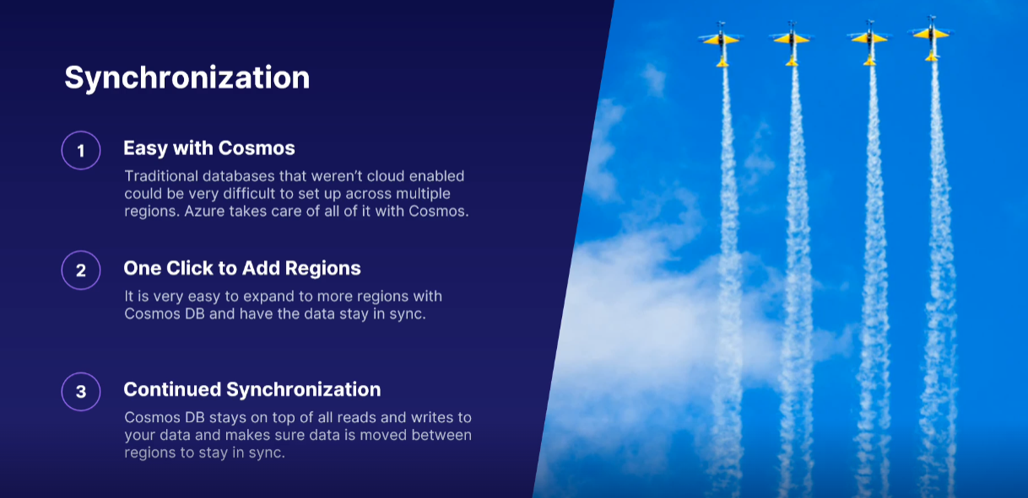



Azure SQL:::

* Microsoft SQL Database was launched in 1989
* Azure will take care of your hardware and infrastructural level needs. That includes servers, storage, network, and everything else infrastructure-related. Azure SQL just sits on top of this and provides you with the business logic and functions you need.
* Azure SQL is a fully fledged database solution, where Azure is managing all the parts that don't have anything directly to do, with managing the data in the database.

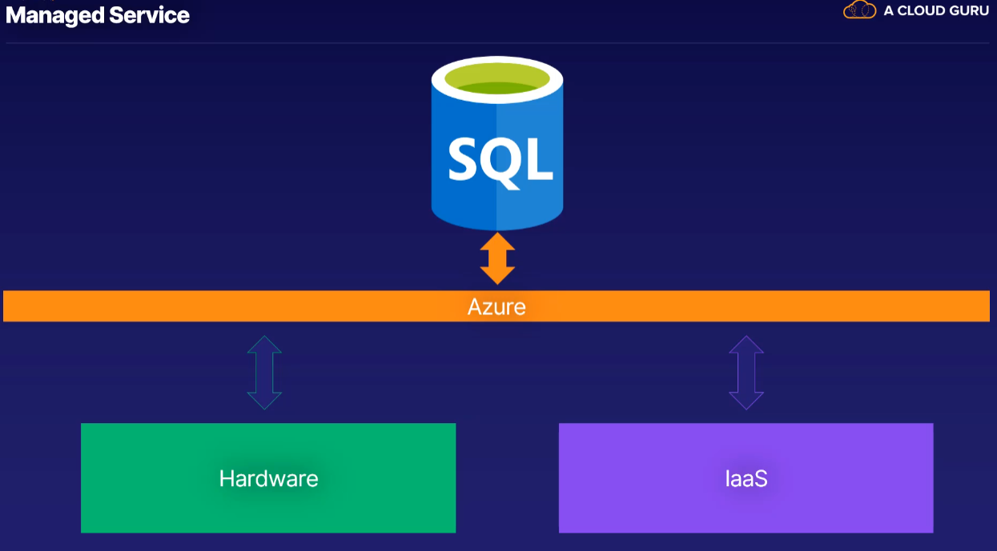

* You can migrate your on-premises SQL server instances directly to Azure, and get all the benefits of managed instances.
* No changes are needed to your on-premises databases

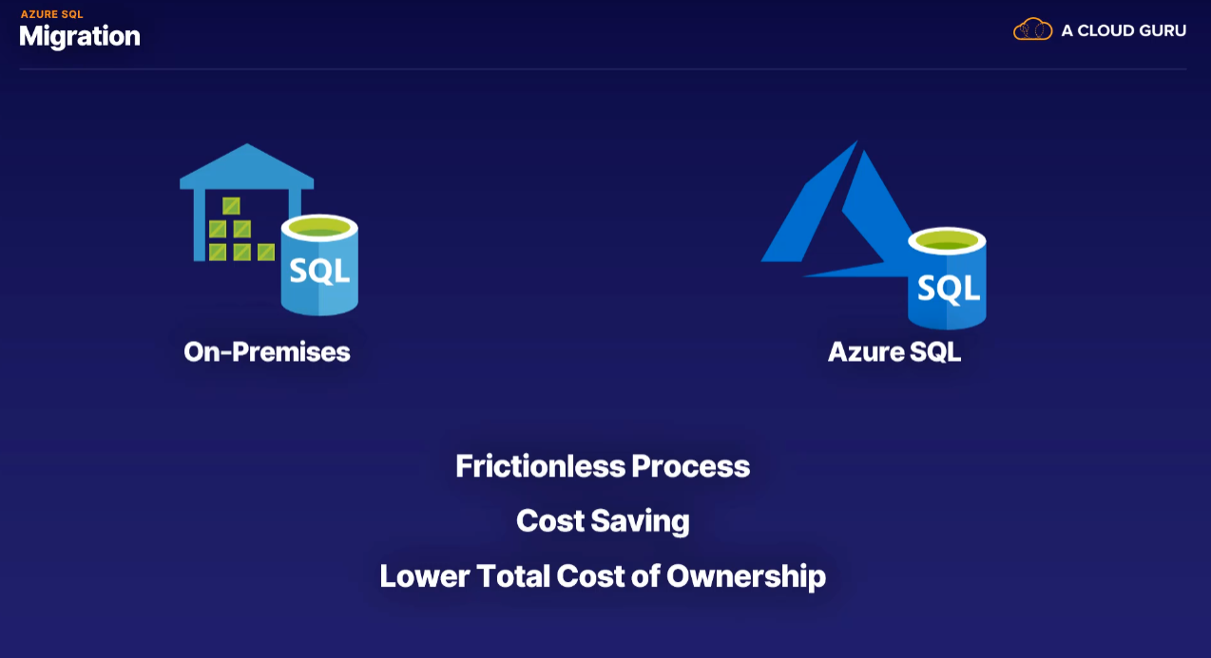

* Frictionless means a smooth operation
* The Total Cost of Ownership (TCO) is the total cost of operating and provisioning cloud infrastructure.

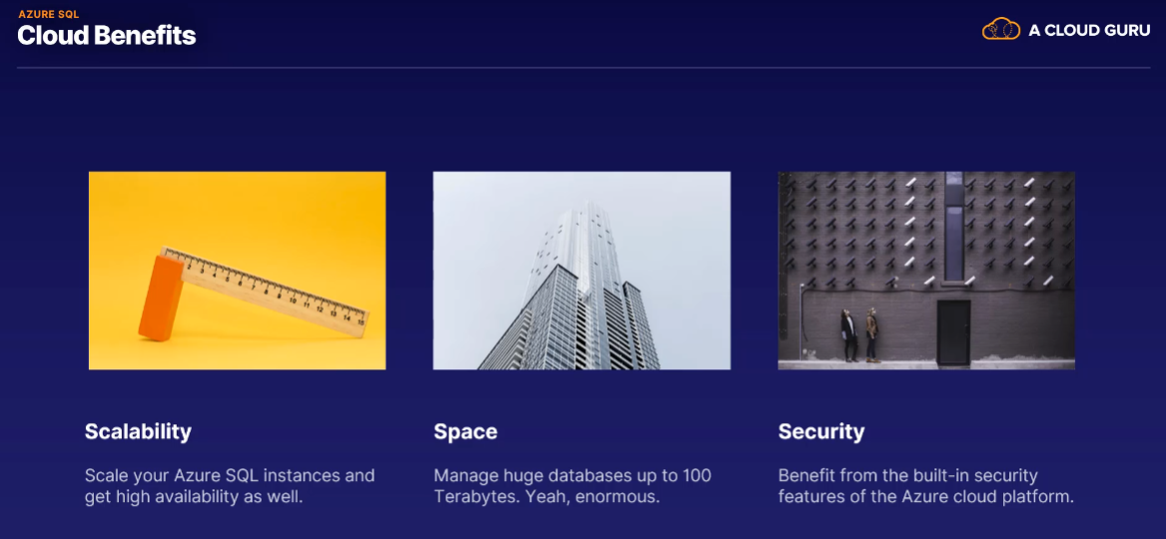

1. Azure SQL database
2. Azure SQL Managed Instance

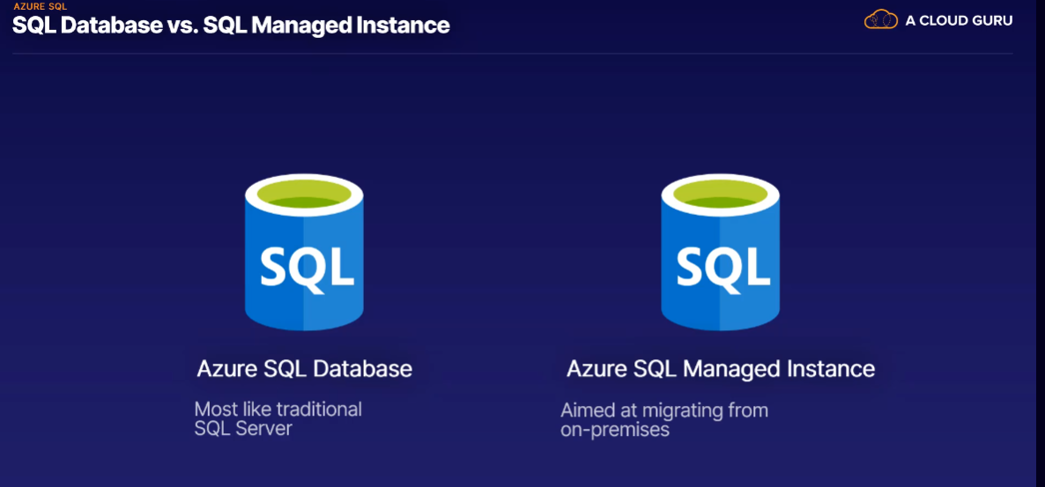

* The SQL Database has more of the traditional SQL features that you might require from SQL server background.
* SQL Managed Instance is meant to bridge the gap between on-premises SQL server and Azure SQL database.

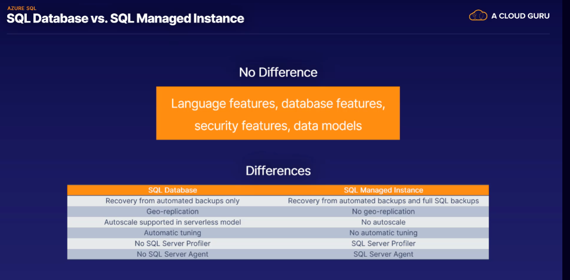

Azure MySQL:::

Azure Mysql is maintained by community

* It is a open source project
* It is a relational database like SQL

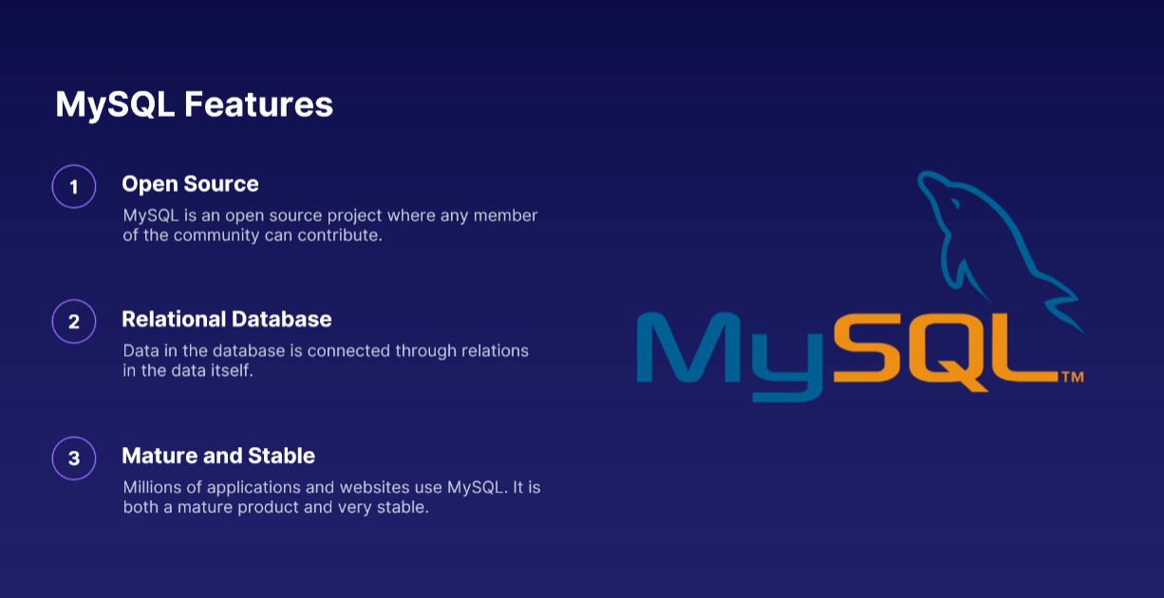

Advantages:::

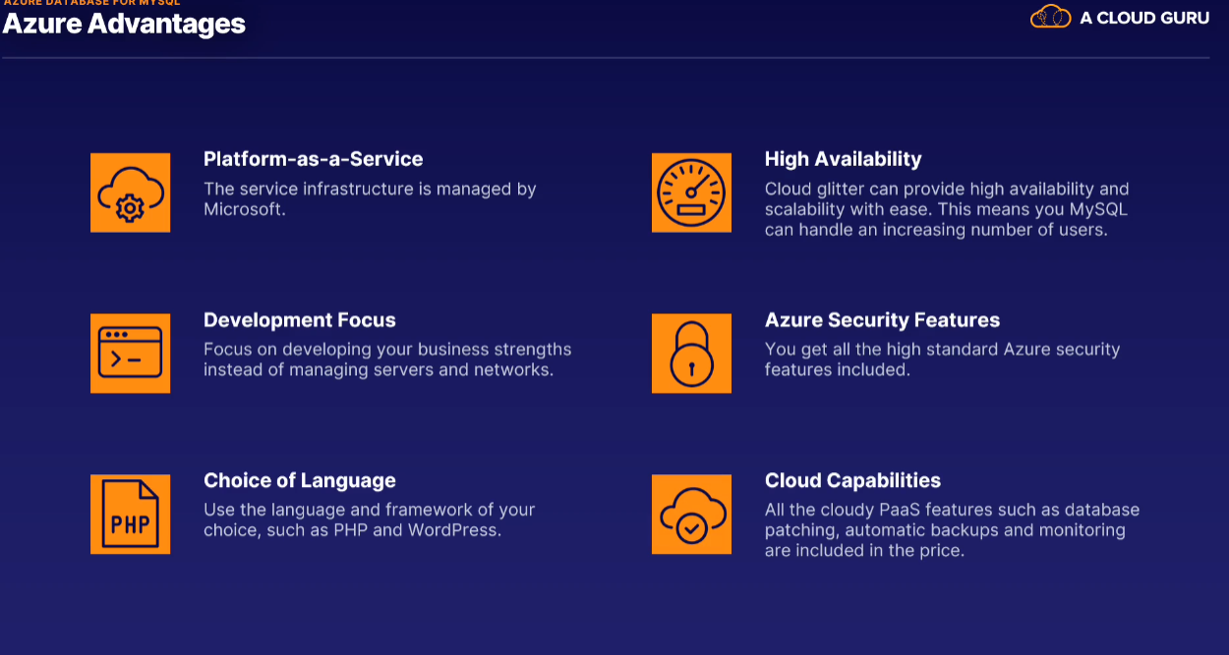

PostgreSQL::

* It is a open source relational database like MySQL.
* The first version was based on a database called “Ingres” and this new version is “post”. So, it become Postgres. It then became PostgreSQL to reflect support of SQL, which is the language used to query the data in the database.
* It is free and very stable
* It’s the default database for macOS

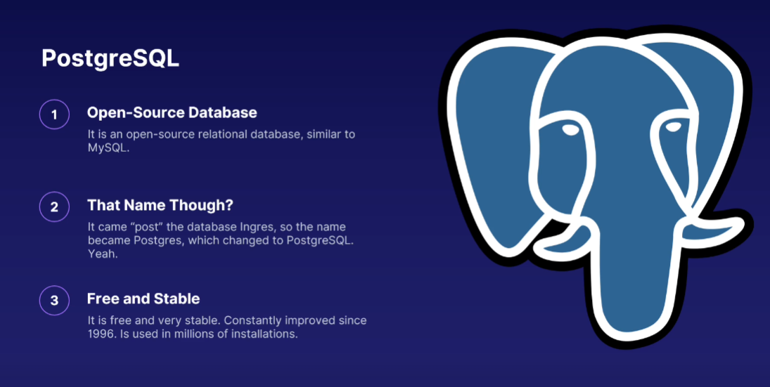

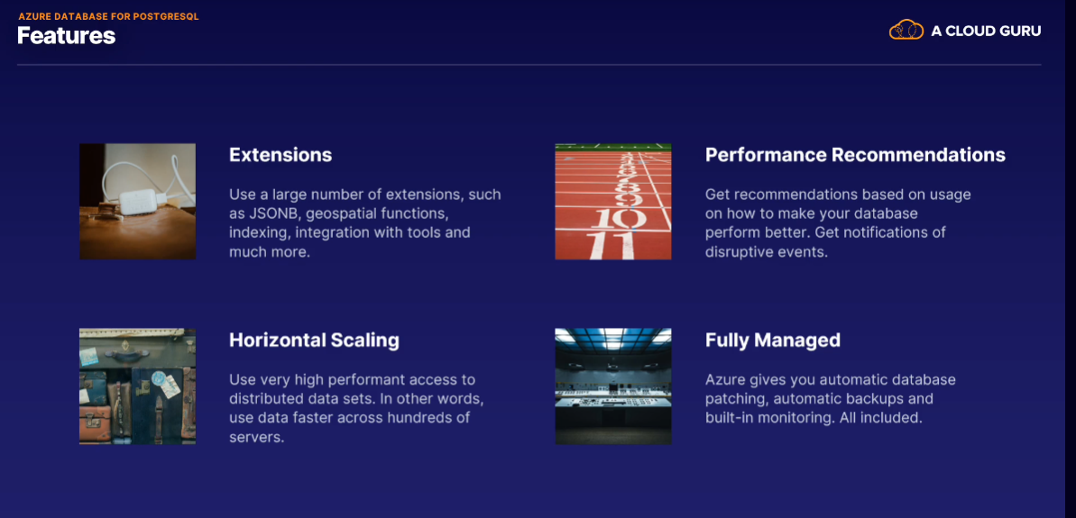

* Some of the best use cases of industries that use Postgres are the financial industry, because it's ideal for online transaction processing. It can also be integrated nicely with mathematical software, such as MATLAB and R.
* Governments use Postgres for geometric data, (also known as GIS, or G-I-S). There's a powerful GIS extension called PostGIS, which provides hundreds of functions to process geometric data in various formats.
* In industrial manufacturing, reliability is everything. If a production site is down due to a failure, it can easily cost millions. PostgreSQL has been a great choice because it can be configured for automatic failover, full redundancy, and almost zero downtime upgrades.

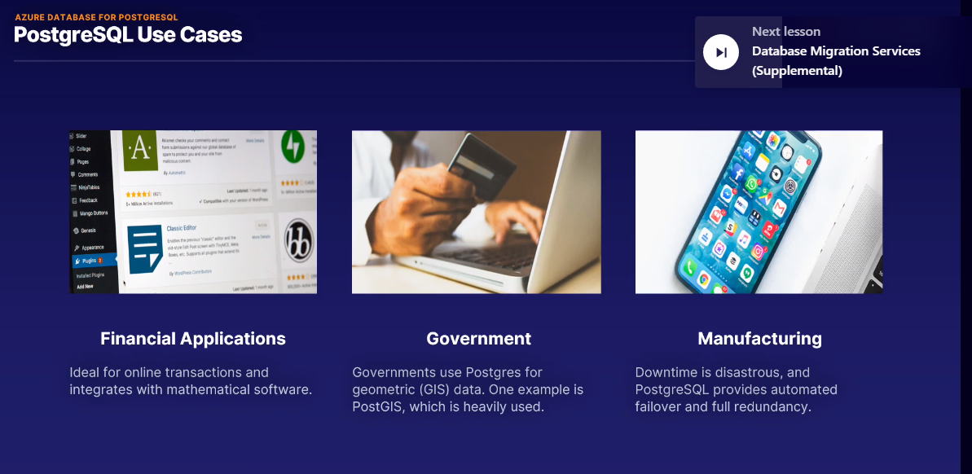

Database Migration Services :::

In the previous lecture, we talked about migrating databases to Azure - in particular, SQL Server. How do you do it, though? With Database Migration Services, of course.

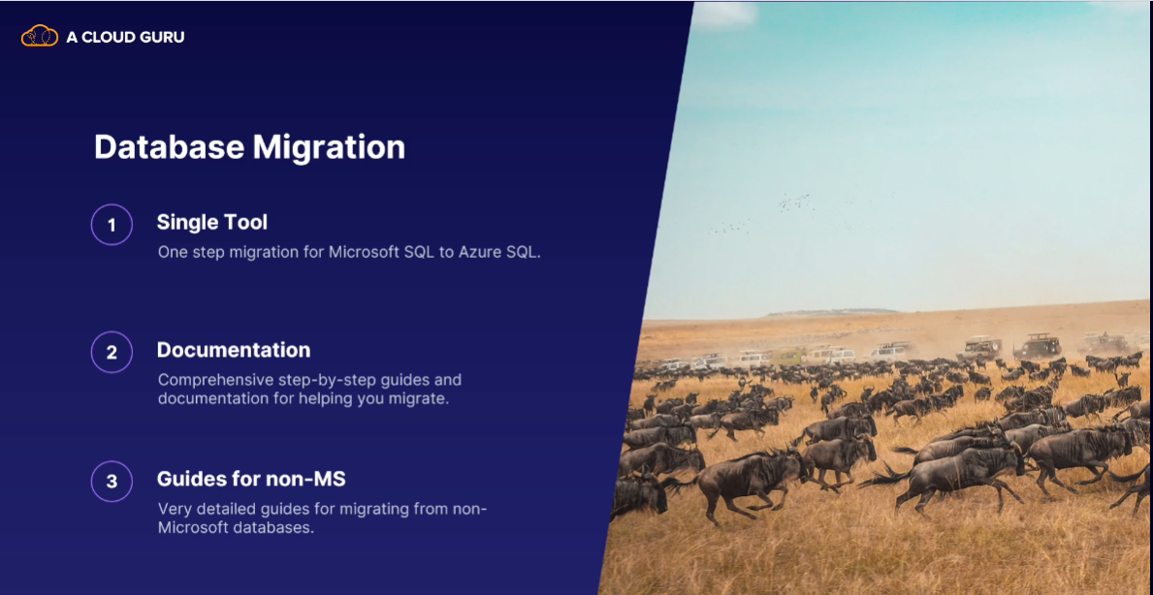

Example::

Let's say your company, Rainbow Dolphins, have everything on-premises.

You have an online shop, and your current database is a Microsoft SQL instance that runs in your server cupboard.

With Database Migration Services, you can simply move the SQL server from your on-premises to a managed Azure SQL instance in the cloud. And say you had a MySQL database in your server cupboard that you wanted to get on to Azure, DMS (Database Migration Service) can help you there too.

In the second scenario,

You might have to do a little bit more of the work manually, but Azure Database Migration Services will have steps for you to follow all the way. It's a very smooth and simple way to get your data on Azure.

